Use Case Realisation Report (Analysis) - Raise Interest
FOR
Volunteer Management System
(VMS)

CLIENT
PROJECT | Volunteer Management System (VMS)Volunteer Management System
TITLE | Use Case Realisation Report (Analysis) - Raise Interest
VERSION | 0.3a0.2a
DATE | 13-Aug-2011
 | ORIGINATOR
 | Name / Signature | Team 8S
 | APPROVAL
 | Name / Signature | Phung Kim Cuong, Dio
Institute of Systems Science |  | Document Reference
25 Heng Mui Keng Terrence  Singapore 119615 |  | VMS/T-1.4.1/1

 | Acceptance
 | Customer Signature |  | Customer Signature
 | Name & Designation |  | Name & Designation
 | Date & Company Stamp |  | Date & Company Stamp

Revision History

Date | Version | Description | Author
12-Jun-2011 | 0.1a | Creation | Team 8S
12-Aug-2011 | 0.2a | Updates | Team 8S
12-Aug-2011 | 0.3a | Updates | Team 8S

Table of Contents

1. Brief Description 3
2. Flow of Events 3
Standard Flow 3
2.1 3
2.2 Exceptions 3
3. Interaction Diagrams 4
3.1 Collaboration Diagram for Raise Interest 4
4. Participating Objects 4
4.1 Volunteer 4
4.2 ProjectDetailsScreen 4
4.3 ProjectController 4
4.4 ProjectInterest 4
4.5 Project 4
Class Diagram 5
5. 5
6. Derived Requirements 5
ANNEX D Amendment History 6

Use Case Realisation Report (Analysis) - Raise Interest

Brief Description
The use case enables registered user to propose new project.

Flow of Events
The standard flow of events for this use case and any exceptions are described in the following subsections. See section 3 for an overview of the participating Actors and Domain Objects.

Standard Flow
Precondition: Volunteer has logged in the system and use case 4.6 has been executed.
This use case provides the user interface related functionality that will be provided to the User, as follows:
- When the Volunteer clicks ‘raise Interest’ button on the ProjectDeatilsScreen, the ProjectDeatilsScreen.raiseInterest() method is triggered.
- ProjectDeatilsScreen.raiseInterest() uses the method ProjectController .addProjectInterest() to create a new project membership request.
- ProjectController will first fetch the projected from the Project Object by using method Project.getprojectId().
- Then ProjectController will use the ProjectInterest.create() method of ProjectInterest object to create an new instance with the volunteer userName and projected.
- Finally, the ProjectController will use ProjectDetailsScreen.displayMsg() to notify the volunteer that a new request has been sent for Project Manager review.
- The use case terminates.

Exceptions
The following exceptions have been identified:
- Invalid Information Format. If any of input information is incompatible, system will display a validation summary for user to make corrections.

Interaction Diagrams

Collaboration Diagram for Raise Interest
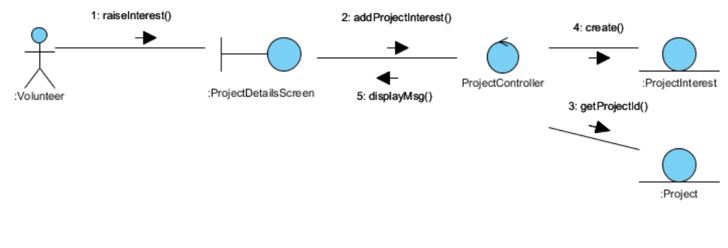
Figure 1 – Collaboration Diagram for Raise Interest

Participating Objects

Volunteer
This entity object stores the details concerning a volunteer of the volunteer organisation. The primary attribute that it holds is the userID.

ProjectDetailsScreen
This boundary object is used to display details of project info that Volunteer selected.

ProjectController
This control object co-ordinates the creation, update, viewing and searching project record in the volunteer management system. It receives requests from the boundary objects allocated for the specific purposes, along with all the necessary details required for the execution of these requests.

ProjectInterest
This entity object stores the request concerning poject membership application. The primary attribute that it holds is the userID and projectID.

Project
This entity object stores the details concerning a project of the volunteer organisation. The primary attribute that it holds is the projectID.

Class Diagram
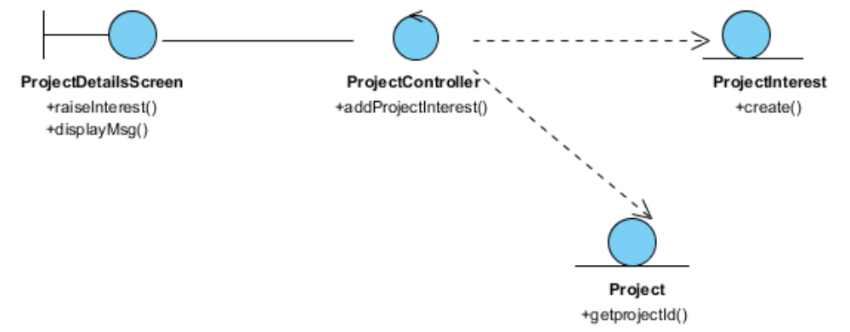
Figure 2 – Class Diagram

Derived Requirements
The Staff office PC (client system), keyboard and mouse will be used to process the project details and view all the system responses.

ANNEX D Amendment History

This is a record of all amendments made to the Document.
Version | Chapter / Section | Page No | Notes of Amendments or Changes

